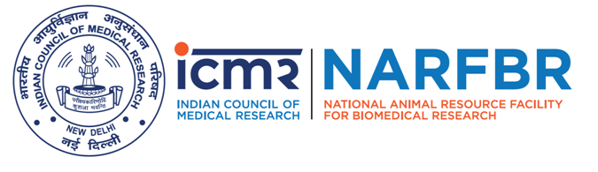 | ICMR- National Animal Resource Facility for Biomedical Research  Department of Health Research, Ministry of Health & Family Welfare  Government of India  Genome Valley, Shamirpet, Hyderabad 500101 Telangana India

PURCHASE PROPOSAL

PP Number |  | : |  | 1. ICMR-NARFBR Main |  |  | : | Yes / No
 |  | : |  | 2. Name of the Unit/ Division |  |  | :
Date |  | : |  | 3. In case of projects, please give Name & ID |  |  | :
Sl.No | Full description of the equipment |  |  |  | Qty | Amount (Approx)
- Is this proposal for a new purchase, additional or replacement ? |  |  |  |  | New / Additional / Replacement
- Whether it is approved by SAC ? if so, give SAC No. & Date.
(In case of Projects, a copy of budget approval may be appended)
- Is similar type of equipment / instrument already available with the division / Unit/ project/ Centre ? kindly establish the functional need for additional equipment & operational status of the existing one ?
- Is required space for installation, electricity load available ? |  |  |  |  | Yes / No

Contd…
- Brief justification for the purchase:
- Is it proprietary item ? |  | Yes / No
- If so, name of the manufacturer or the Indian agent with specifications / catalogue No. etc., be given ?
Signature of Indenter  Name :  Designation: | Recommendations of the Unit / Division Head & Signature

Administrative Approval of the above purchase
Approved / Not Approved

DIRECTOR

